**Appendix: Unique Acoustic Encounters**

**ADRIFT Unknown Whale**

**Overview**

Within an April 2023 ADRIFT dataset, an acoustic event from an unidentified species of baleen whale extended nearly the entirety of the drift. Over several days, a diverse array of low-frequency calls were produced with relatively consistent intensity. Unlike conventional fixed recorders constrained by the transit time of passing animals, drifting recorders present an unprecedented opportunity for prolonged observation and data collection of marine mammal acoustic behavior.

**Analysis Summary**

The dataset annotation involved quantifying calls throughout the encounter and annotating the entire dataset in Raven for future analysis and to create a comprehensive call catalog. The animated map below tracks the drifter's path along the Oregon coast, displaying the counts of calls recorded at each GPS location.



The features of the calls detected in this event resemble those produced by various baleen whale species, complicating their identification compared to more distinct and extensively documented calls. However, the resulting call catalog offers a chance to advance the investigation into identifying this species further. With measurements provided by the annotated data in Raven, researchers have the opportunity to meticulously assess the repertoire and refine their understanding. A *subset* of the call catalog is indicated below.

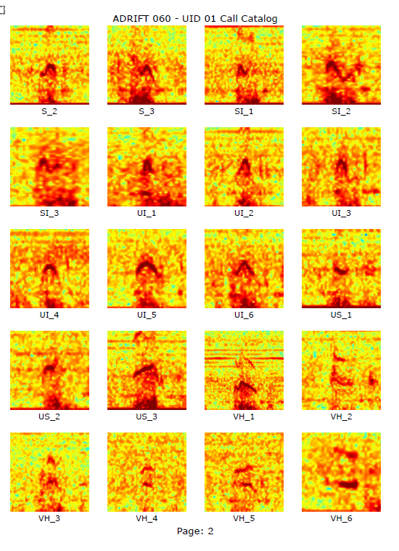

**Relevance and Opportunities**

This analysis holds significance for both BOEM and NOAA on multiple fronts. Firstly, it underscores the invaluable contribution of drifter-based acoustic monitoring, showcasing its capability to capture prolonged encounters that fixed recorders and towed arrays cannot achieve. The mobility of the recorder not only enhances our understanding of habitat utilization by this whale species but also enables the collection of extensive call datasets during such encounters, crucial for species identification and habitat assessment, especially for presumed endangered species.

In the immediate future, this annotated data can be shared and consulted with other researchers to explore potential matches with other datasets, enriching insights. Furthermore, the annotation presents an opportunity for machine learning classification of call repertoires, facilitating species identification. Another promising avenue is the utilization of this data for training deep learning models to recognize similar call types. This unique acoustic encounter exemplifies the benefits of mobile recording devices for monitoring protected resources, emphasizing their importance in conservation efforts.